Managing congestion control in our project
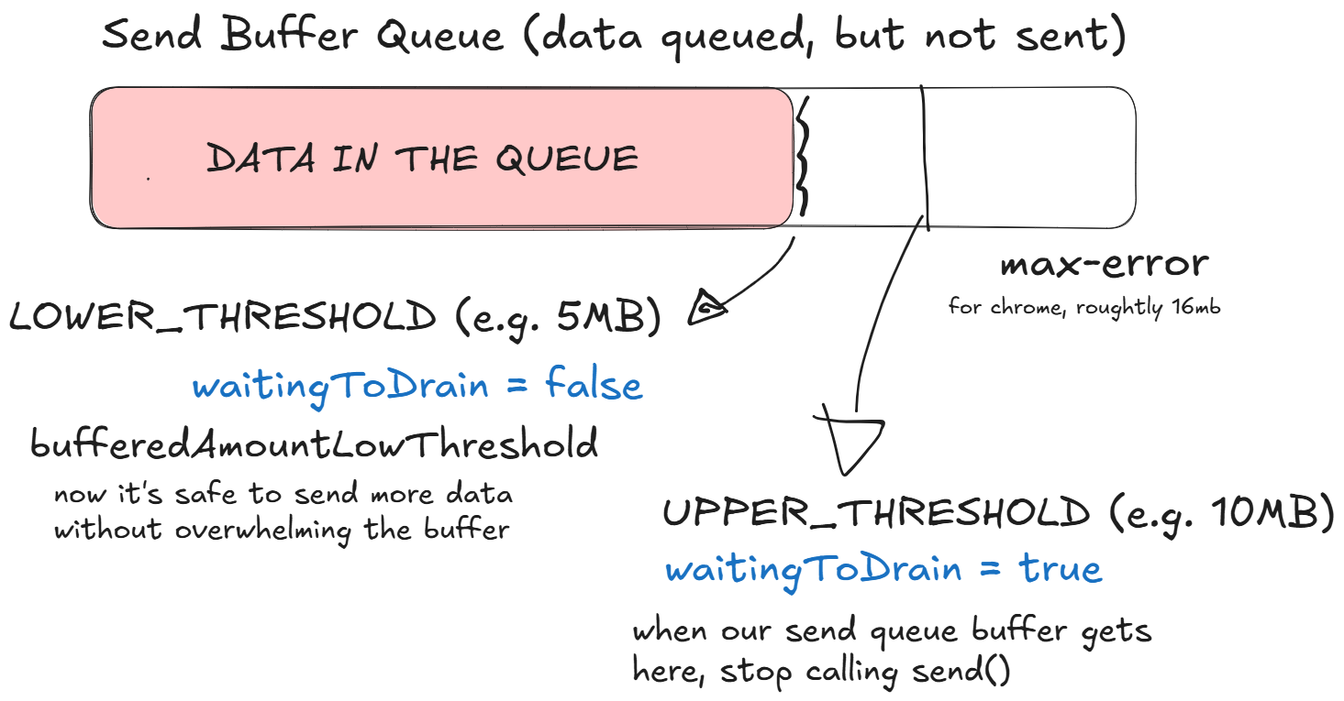
The bufferedAmount and bufferedAmountLowThreshold properties work together to manage flow control in a WebRTC DataChannel. The bufferedAmount indicates how many bytes are currently queued but not yet sent, while bufferedAmountLowThreshold sets the threshold considered “low.” When bufferedAmount falls to or below this threshold, a bufferedamountlow event fires, signaling it is safe to send more data. This mechanism prevents the send queue buffer overflowing, by pausing sending when the buffer is too full and resuming when there is enough space.
It makes sense, right?
How are we going to use this in our project?
Unfortunately, browsers don’t expose their internal maximum buffer sizes for send queues. Therefore, we have to define our own thresholds.
We'll set an upperThreshold - think of it as a "high water mark" - to pause sending as soon as the buffered amount hits that limit. When the buffer drains down to a lower threshold (bufferedAmountLowThreshold), we'll listen for the bufferedamountlow event, which signals it's safe to send more data again.
We have already seen that in Chrome, we started having issues when the send queue buffer was around 16MB in size. So, to be safe, why don't we set the upperThreshold to 10MB and the bufferedAmountLowThreshold to 5MB? This makes sense to me. Here's why:
- The 10MB upper limit acts as a safety margin, keeping us below Chrome’s internal cap to avoid errors.
- The 5MB low threshold gives us an early warning to resume sending, ensuring we don’t wait too long once the buffer has drained enough.
Basically, this setup strikes a good balance: we keep enough data in the pipeline for efficiency, but not so much that it causes lag or resource strain.

